

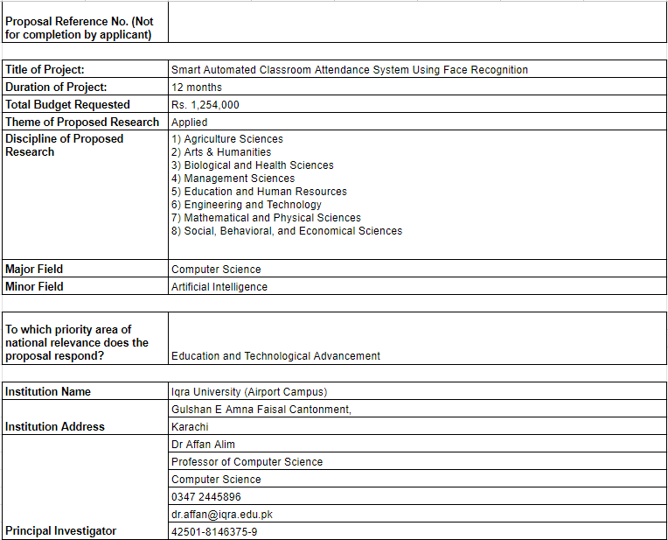

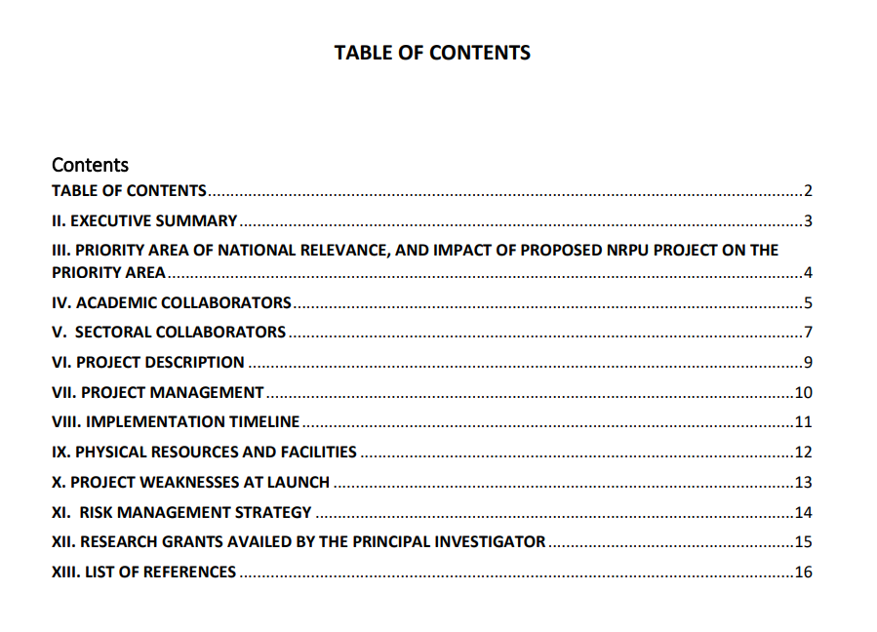

II. EXECUTIVE SUMMARY
The proposed project, "Smart Automated Classroom Attendance System Using Face Recognition," aims to revolutionize the traditional classroom attendance system through the integration of advanced facial recognition technology. This system will automate the process of attendance logging, enhancing efficiency and accuracy while addressing the critical challenge of attendance management in educational institutions.

Research Questions and Challenges
- Leverage facial recognition technology for automated classroom attendance.
- Address technical and logistical challenges of a multi-camera attendance system.
- Integrate with databases for operation.

Research Objectives
- Using accurate face recognition using YOLO (You only look once) or Roboflow.
- Integrate with classroom cameras for real-time attendance logging.
- Normalize attendance data using a rational database.
- Create a user-friendly interface.
- Implement a notification system for attendance anomalies.
- Ensure support for multiple cameras.

Activities to Achieve Project Goals
- Utilize face recognition using resources (YOLO or Roboflow).
- Implement a centralized, normalized database.
- Design user interface

III. PRIORITY AREA OF NATIONAL RELEVANCE, AND IMPACT OF PROPOSED NRPU PROJECT

National Relevance
- Priority Area: Enhancing educational management through technology.
- Importance: Improves attendance management, reduces administrative workload, and increases student accountability.

Contributions to Research
- Face Recognition Technology: Advances in accuracy and real-time processing.
- Camera System: Innovations in technical and logistical implementation.
- Database: Perform operation with system database.

Timeliness and Importance
- Current Needs: Addresses pressing challenges in educational administration.
- Research Significance: Timely contribution to educational technology and resource management.

Socioeconomic Development
- Impact: Supports efficient management of educational resources.
- Benefits: Enhances student accountability, leading to improved educational outcomes.
- National Context: Facilitates modernization of educational infrastructure in Pakistan.

IV. ACADEMIC COLLABORATORS

Principal Investigator (PI) and Co-PIs
- PI: Muhammad Ahmed
  - Role: Project leadership and oversight
  - Skills: Expertise in facial recognition technology and educational systems
  - Responsibilities: Overall project coordination, system integration, and pilot testing
- Co-PI 1: Syeda Aliza Ali
  - Role: Technical advisor
  - Skills: Machine learning and database normalization
  - Responsibilities: Data management
- Co-PI 2: Faiq Ali Siddiqui
  - Role: Technical advisor
  - Skills: Machine learning and database normalization
  - Responsibilities: Data management
- Co-PI 2: Maryam Rehan
  - Role: User interface and user experience design
  - Skills: UI/UX design and human-computer interaction
  - Responsibilities: Development of user-friendly interfaces for the system

Collaboration Details
- Type: Collaboration
- Institutions Involved: Iqra University
- Sustainability: Regular meetings, shared resources, and long-term research plans

Role and Contributions
- Disciplinary Expertise: Each collaborator brings specialized knowledge in their field
- Experimental Equipment: Access to camera and computing facilities
- Software Sharing: Exchange of face recognition and database management software
- Technical Expertise: Combined expertise to tackle project challenges

Additional Resources
- Research Grants: Existing grants from educational and technology funding bodies
- Support: Institutional support for research activities and infrastructure



V. SECTORAL COLLABORATORS
XYZ Technology Solutions
- Role: Technology provider
- Skills: Expertise in camera systems and real-time data processing
- Responsibilities: Supplying and maintaining camera equipment, providing technical support
ABC Educational Services
- Role: Educational consultant
- Skills: Integration of educational technologies
- Responsibilities: Advising on system integration with databases
DEF Software Solutions
- Role: Software development
- Skills: Expertise in database management and software integration
- Responsibilities: Advising on the database and design the software with the systems

VI. PROJECT DESCRIPTION
Methodology:
- Year 1:
  - Utilize facial recognition; pilot testing with single-camera system.
  - Expand to camera setup; integrate with database.
  - Full-scale deployment and refinement; user training and feedback integration.
- Milestones: Coding completion, system integration, pilot testing, deployment.
- Deliverables: Working prototypes, integrated system, user manuals.
Project Team and Partnerships:
- Capacity: Experienced faculty in AI and database management; collaboration with tech companies and educational consultants.
- Facilities: Access to labs with necessary hardware and software; partnership for camera systems and technical support.
Plans for Dissemination:
- Data Management: Data collected through attendance logs; maintained and shared via secure platforms.
- Dissemination: Publications in academic journals; reports to educational policymakers; presentations in conferences.
Ethical Considerations:
- Privacy: Ensuring student data privacy through secure data handling.
- Informed Consent: Obtained from participants prior to data collection, with detailed information on data usage.

VII. PROJECT MANAGEMENT

Project Management Structure:
- Principal Investigator (PI): Oversees project execution, manages team, ensures milestones are met.
- Project Coordinator: Handles day-to-day operations, communication, and scheduling.
- Technical Leads: Specialists in facial recognition, database management, and UI development.
- Support Staff: Assist with data entry, technical support, and logistics.
Motivation and Incentives:
- Collaborators: Regular progress meetings, recognition of contributions, performance-based incentives.
- Communication: Weekly updates, collaborative platforms for sharing results and addressing challenges.
University Support:
- Vice-Chancellor/Rector: Provides strategic guidance, access to university resources, and administrative support.
- Additional Support: Funding opportunities, access to research facilities, and promoting the project within academic circles.

VIII. IMPLEMENTATION TIMELINE

• Deep Learning Approach for Face Recognition
- Duration: Months 1
- Deliverable: Trained facial recognition model.
• Deep Learning Approach for Feature Extraction
- Duration: Months 2
- Deliverable: Feature extraction module.
• Model Development
- Duration: Months 3
- Deliverable: Complete face recognition model.
• Insertion Query Implementation
- Duration: Month 4
- Deliverable: Insertion queries for database.
• Database and Website Integration
- Duration: Months 5
- Deliverable: Integrated database and website.
• CCTV Setup for Face Detection and Segmentation
- Duration: Months 6
- Deliverable: Fully operational CCTV system.

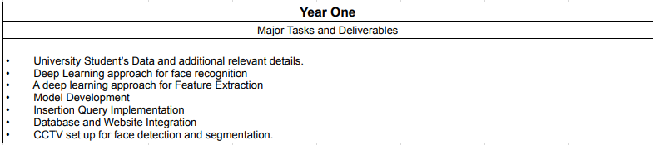
IX. PHYSICAL RESOURCES AND FACILITIES
• Available Resources:
- Computer Labs: Equipped with high-performance computers for deep learning model training.
- CCTV Infrastructure: Existing cameras to be integrated with the facial recognition system.
- Database Servers: For data storage and management.
• Major Equipment Expenditures:
- High-Performance GPUs: Estimated cost: PKR 100,000 for deep learning computations.
- Additional CCTV Cameras: Estimated cost: PKR 84,000 for enhanced coverage.
• Maintenance Plan:
- During Project: Routine checks and software updates included in project budget.
- Post-Project: University IT department to handle ongoing maintenance.
• Facilities Contribution to Workplan:
- Computer Labs: Facilitate algorithm development and testing.
- CCTV Infrastructure: Enable real-time face detection and recognition.
- Database Servers: Support data normalization and attendance logging.

X. PROJECT WEAKNESSES AT LAUNCH

- Limited Initial Data for Training:
  - Strategy: Collaborate with other institutions to access larger datasets and conduct pilot studies to gather initial data.
- Utilize Challenges with System:
  - Strategy: Assign a dedicated team for seamless integration and testing, ensuring compatibility with database.
- High Initial Setup Costs:
  - Strategy: Seek additional funding or grants to offset costs, and prioritize essential equipment purchases.
- Potential Privacy Concerns:
  - Strategy: Develop clear privacy policies and obtain informed consent from participants, emphasizing data security measures.
- Technical Skill Gaps in Team:
  - Strategy: Conduct targeted training sessions and workshops to enhance team skills in deep learning and database management.

XI. RISK MANAGEMENT STRATEGY
• Potential Risks and Mitigation:
- Technical Failures:
  - Strategy: Implement regular system maintenance and backups; establish a technical support team.
- Data Privacy Issues:
  - Strategy: Ensure compliance with data protection laws and utilize encryption; conduct regular audits.
- Budget Overruns:
  - Strategy: Monitor expenses closely; adjust the budget allocation as needed and seek additional funding if necessary.
• Unexpected Risks:
- Identification and Response:
  - Strategy: Establish a risk monitoring team to identify emerging risks; develop a rapid response protocol.
- Mitigation:
  - Strategy: Hold regular meetings with stakeholders to assess and address new risks promptly.
• Collaboration with Leadership:
- Institutional Support:
  - Strategy: Engage university leadership in strategic planning; ensure open communication channels for timely support.
- Collaborator Involvement:
  - Strategy: Foster strong partnerships with collaborators through regular updates and shared responsibilities in risk management.

XII. RESEARCH GRANTS AVAILED BY THE PRINCIPAL INVESTIGATOR


XIV. PROPOSED PROJECT BUDGET

